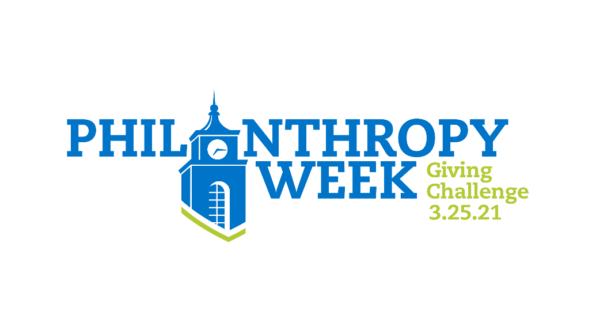

Sample Communications

Save the Date: Text and Email
Save the Date for the Philanthropy Week Giving Challenge on 3/25/21! This week is when the entire community comes together to honor their Bentley experience and recognize what matters most, all while encouraging today’s Falcons to pay it forward. When 350 of us give back, we’ll unlock $20,000 for Bentley. Make your gift and spread the word about Philanthropy Week. Together, we give. bentley.edu/philanthropy-giving-challenge

Philanthropy Week Giving Challenge Text
Today kicks off Philanthropy Week! Honor the part of the Bentley experience that matters most to you by making a gift. You can help unlock $20,000 for Bentley, and you can give to an area that means a lot to you. Join me by making a gift and spreading the word. bentley.edu/philanthropy-giving-challenge

Philanthropy Week Giving Challenge Email
Dear NAME,
Together, we give. When 350 of us come together to give back in honor of Philanthropy Week, we can unlock $20,000 for Bentley! You can use your gift to honor the part of the Bentley experience that matters most to you. Please join me and hundreds of other donors in making your gift. Then, spread the word with your fellow Falcons to make sure we unlock this generous gift! Where will you make your impact? bentley.edu/philanthropy-giving-challenge

Save the Date: Social Media
Save the Date: the Philanthropy Week Giving Challenge is 3/25/21! When 350 of us give back, we’ll unlock $20,000 for Bentley. Join me to make your gift and spread the word about Philanthropy Week. Where will you make your impact? bentley.edu/philanthropy-giving-challenge

Philanthropy Week Giving Challenge Social Media
Today is the Philanthropy Week Giving Challenge! Be one of 350 donors to unlock $20,000 for Bentley. Join me to make your gift and spread the word. Where will you make your impact? bentley.edu/philanthropy-giving-challenge

