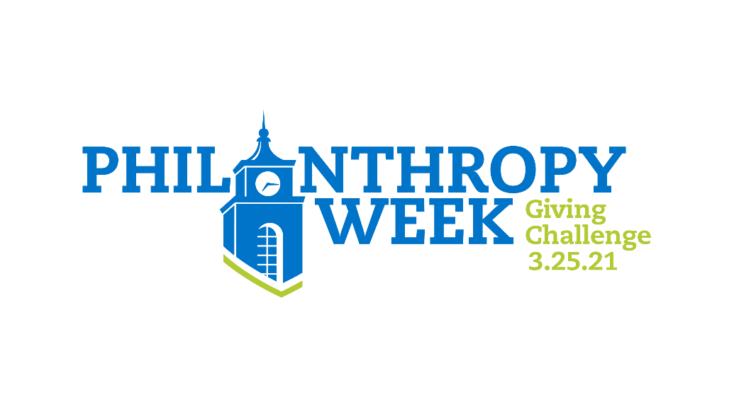

Communication Schedule

Date | Vehicle | Action
March 11 | Email and Social Media | - Make your gift  - Rally your friends:  “Save the date for Philanthropy Week”  “I already made my gift!”
March 22 | Email and Social Media | Make your gift, if you haven’t already, and encourage others to join the challenge. “Today kicks off Philanthropy Week! Where will you make your impact?”
March 25 | Email and Social Media | Make your gift, if you haven’t already, and encourage others to join the challenge. “TODAY is the Philanthropy Week Giving Challenge! If 350 of us make a gift by midnight, we’ll unlock $20,000 for Bentley! Where will you make your impact?”

