Scheduling an Academic Advising Appointment - Academic Services
Step 1: In Workday choose the Academics portal.

Step 2: Click on Academic Advising Appointments on your Workday account.
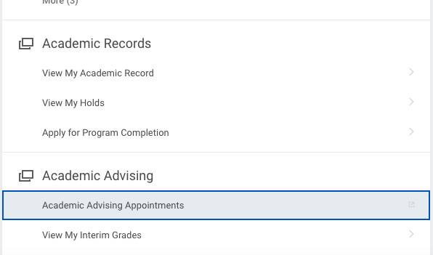

Step 3: Click on Make Appointment under the Bentley logo (on the upper right side of the screen).

Step 4: Complete the following fields and click Find Available Time. You may need to scroll down to find the appropriate service.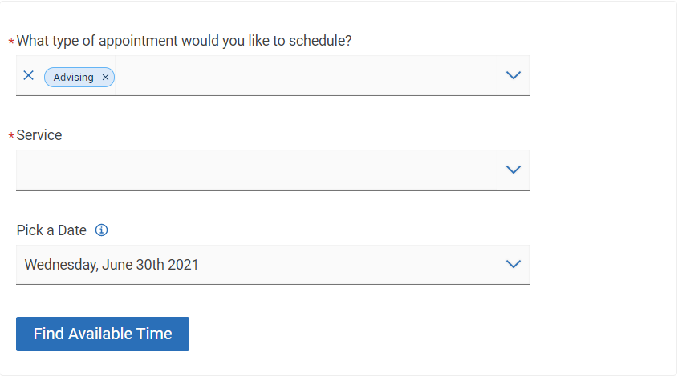
Please note: Advising will be preselected for you and does not need to be changed.
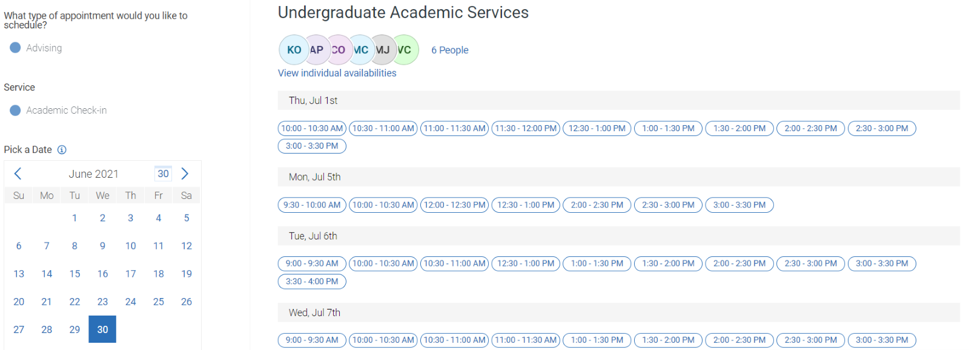
Step 5: Choose a time that is convenient for you or select view individual availabilities to see a specific advisor’s availability.
Please note: if do not select a preferred advisor you will be assigned to an advisor with availbility during your preferred time.

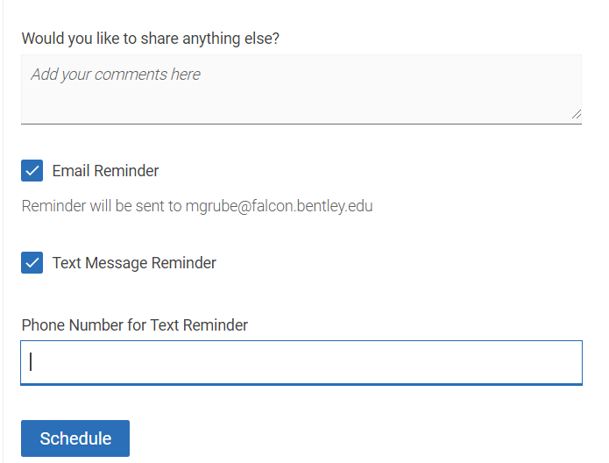
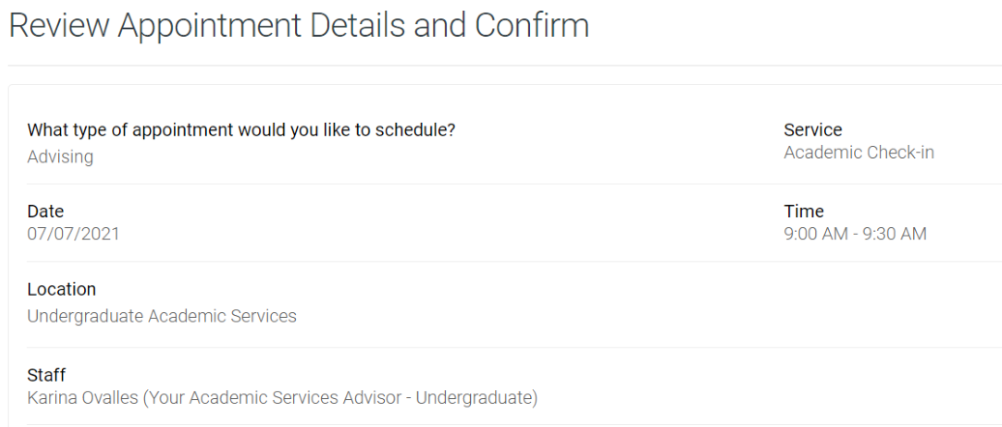
Step 6: Review your appointment details and click schedule.

