COURSE AWAY REQUEST FORM
Submission Process:
- Complete all required (*) sections of Course Away Request Form, including course descriptions for each class in the applicable box
- IMPORTANT: save Course Away Request Form to your computer as LAST NAME, FIRST NAME TERM (i.e. Smith, Joe Summer 2022) before submitting
- Obtain course syllabus for any course from a business department or NASC course; update syllabus file name to LAST NAME, FIRST NAME, COURSE #
- Email the completed Course Away Request Form and applicable syllabi, as attachments, to GA_CourseAway@bentley.edu
Note: this form should only include courses that have not already been submitted/reviewed for the term indicated below.
Last Name* |  |  | First Name* |  |  | Bentley ID number* |  | Class Year
Email Address* |  |  | Permanent/Home Address (Street, City, State, Zip)*
Maximum Total # Credits Away¹:* | Maximum Total # Courses Away¹:* |  | # Courses Away Completed:* | Term Course(s) to be Taken² (ex. Summer 2022):* |  |  | # Courses Away to be Taken for this Term:*
Course Away Institution & Location* |  | Course Dept & #*  Ex: HIST 101 | Course Name*  Ex: World History | # Semester Credits*  Ex: 3 cr. | Bentley  Equivalent*  Ex: HI 200 | Office Use Only:  Course Approved³ or Denied  If Approved, Bentley Equivalent

¹ Once enrolled at Bentley, students can transfer in (through Course Away) up to 10% of their Bentley program from other institutions. Students must complete a minimum of 60 credits (20 courses) at Bentley to meet graduation requirements. How to calculate 10% of your Bentley program is available at https://www.bentley.edu/offices/academic-services/course-away. You are responsible for adhering to the Course Away credit maximum.
²Course away start and end dates must be within Bentley’s intersession period or summer term.
³Any approvals are for the course in question, not your eligibility to take the course. See footnote 1 above.
Copy & paste course descriptions for each class here:*

I understand the Course Away policies and procedures (listed above and on following page) and accept responsibility for adhering to these guidelines.*
______________________________________________________ ______
Student Signature* Date*

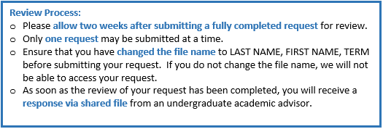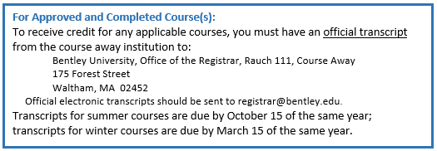

Office Use Only:
Comments

Reviewed By | Date

