COURSE AWAY REQUEST FORM
Submission Process:
- Complete all required (*) sections of Course Away Request Form, including course descriptions for each class in the applicable box
- IMPORTANT: save Course Away Request Form to your computer as LAST NAME, FIRST NAME TERM (i.e. Smith, Joe Summer 2023) before submitting
- Obtain course syllabus for any course from a business department or NAS Lab course; update syllabus file name to LAST NAME, FIRST NAME, COURSE #
- Email the completed Course Away Request Form and applicable syllabi, as attachments, to GA_CourseAway@bentley.edu
Note: this form should only include courses that have not already been submitted/reviewed for the term indicated below.
Last Name* | First Name* | Bentley ID number* | Class Year | Email Address* | Permanent/Home Address (Street, City, State, Zip)*
How many credits can you take away by calculating 10% of your¹ Bentley program* |  |  |  | # Courses Away Completed:* | Term Course(s) to be Taken² (ex. Summer 2023):* | # Courses Away to be Taken for this Term:*
Course Away Institution & Location* | Course Dept & #*  Ex: HIST 101 | Course Name*  Ex: World History | # Semester Credits*  Ex: 3 cr. | Bentley  Equivalent*  Ex: HI 200 | What requirement are you seeking to fulfill?  Ex: Context & Perspective, Unrestricted, Arts & Science Elective, etc. | Office Use Only:  Course Approved³ or Denied  If Approved, Bentley Equivalent

¹Once enrolled at Bentley, students can transfer in (through Course Away) up to 10% of their Bentley program from other institutions. Students must complete a minimum of 60 credits (20 courses) at Bentley to meet graduation requirements. How to calculate 10% of your Bentley program is available at https://www.bentley.edu/offices/academic-services/course-away. You are responsible for adhering to the Course Away credit maximum.
²Course away start and end dates must be within Bentley’s intersession period or summer term.
³Any approvals are for the course in question, not your eligibility to take the course. See footnote 1 above.
Copy & paste course descriptions for each class here:*

IMPORTANT: PREREQUISITE WAIVER PRACTICE
If a student's intended course away is needed to meet the co-or prerequisite for a course at Bentley, the prerequisite waiver form must be accompanied by documentation confirming that the student is registered for the course away. The prerequisite waiver form and the proof of course registration must be submitted to the Office of the Registrar at registrar@bentley.edu. Without this documentation, you will not be permitted to register for the Bentley course with the applicable co-or prerequisite

IMPORTANT: SUMMER COURSE OVERLOAD POLICY
Students may enroll in no more than 13 credits of summer course work, 16 if their current GPA is at least a 2.7. This includes summer credits earned at Bentley*, regardless of course delivery mode, transfer credits earned at another institution through the Course Away process, or a combination of Bentley and Course Away (transfer) credits. Students taking courses for credit beyond this limit may not apply the additional course credits to their academic program.
* Summer courses are defined as courses taken between the end of the Bentley spring semester until the beginning of the Bentley fall semester in any given calendar year. Bentley summer courses include May intensives.
I understand the Course Away policies and procedures (listed above and on following page) and accept responsibility for adhering to these guidelines.*
______________________________________________________ ______
Student Signature* Date*

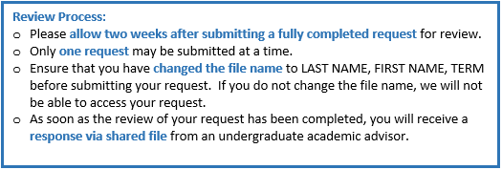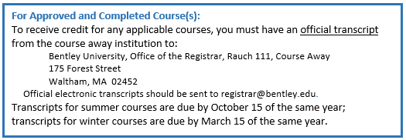

Office Use Only:
Comments

Reviewed By | Date

